北大光华-马里兰大学2012中国商业计划书大赛简介

- About the University of Maryland’s Robert H. Smith School of Business
The Robert H. Smith School of Business is an internationally recognized leader in management education and research. One of 12 colleges and schools at the University of Maryland, College Park, the Smith School offers undergraduate, full-time and part-time MBA, executive MBA, executive MS, PhD and executive education programs, as well as outreach services to the corporate community. The school offers its degree, custom and certification programs in learning locations in North America and Asia.

- About the Dingman Center for Entrepreneurship
The Dingman Center has been a hub of campus and regional entrepreneurial activity for 25 years. Among the Dingman Center’s resources are its Capital Access Network (CAN), a pipeline that connects startups from regional tech councils, incubators and state-funded institutions with a network of more than 40 active, accredited angel investors and venture capitalists for early-stage capital. The center also helps lead the University of Maryland’s Technology Transfer programs and provides MBA and undergraduate students at the Smith School with practical experiences and opportunities to pitch their business ideas, obtain feedback from experienced entrepreneurs-in-residence and access funding.

- About the 7th Annual China Business Plan Competition

- Entrepreneurial Skills
- Gain exposure to and interact with early-stage firms and entrepreneurs at company visits and group meals.
- Develop a business idea that is based in China or leverages Chinese resources and present it to expert judges for feedback.
- International Experience
- Compete against 150+ top Chinese MBA students in the 7th Annual China Business Plan Competition for a chance to win cash prizes
- Get chance to have pre-travel classes and advisory sessions to prepare for the China Business Plan Competition by John LaPides, senior advisor from Robert H. Smith School of Business.
- All in English

- Wonderful Journey
- Travel to Beijing, living in Peking University. The competition will be held on January 5.
- Other days will be spent at company visits, sightseeing and cultural activities.
- Financial support from the School of Management, Zhejiang University

- Your competitor
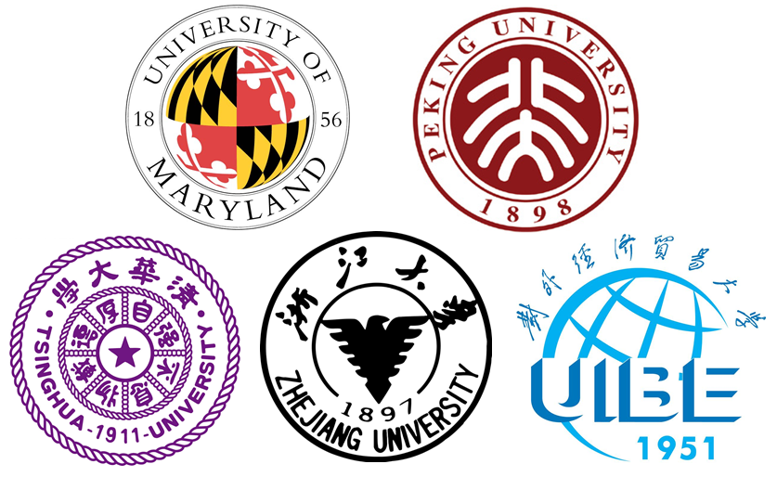
- You will compete against students from: University of Maryland, Peking University, Tsinghua University, and University of International Business and Economics.

- About Judging
- Each entry consists of a six-minute PowerPoint presentation in English that answers the following:
Problem -Market -Solution -Team
Competition -Risk of Viability -Use of Funds
- Teams will present their ideas before a panel of judges from the Dingman Center and venture capital firms and successful businesses from China and the United States.
- Winners will be determined by their ability to meet defined criteria, present and respond to questions—as well as capacity to implement the business idea

